WEEK 2 – OVERVIEW OF C++ LANGUAGE

Last Lecture

- Unix File System
- Major Unix commands
- One question:
- Check processes: ps
- Kill a process: kill pid_a_process

Outline of This Week’s Lecture

- C-portions of C++ Languages
- Basics of C++
- Control Structures and Functions
- Advanced Data
-----------------------------------------------------------
- Object-oriented Programming
- Classes
- Overload Operators
- Inheritance
- Virtual Members
- Dynamic Binding

UNIT 1: C-PORTIONS OF C++ LANG

Main Objective: Overview of C-portions of C++ language

Structure of a C++ program

// my first program in C++

#include <iostream.h>

int main ()
{
cout << "Hello World!";
return 0;
}
Hello World!

Anybody has a question?
- #include <iostream.h>
Sentences that begin with a pound sign (#) are directives for the preprocessor.
- What is iostream.h ? <iostream.h> vs <iostream>
- Difference between
#include “xxx.h” vs #include <xxx.h>
- What is cout ? What is cin ?
- How many main()

/* my second program in C++
with more comments */

#include <iostream.h>

int main ()
{
cout << "Hello World! "; // says Hello World!
cout << "I'm a C++ program"; // says I'm a C++ program
return 0;
}

Hello World! I'm a C++ program

- Two ways to make a comment. Which one is native to C++?
- How to change a line when using cout?

Variables, Data types, Constants

- Variable
- Definition: a portion of memory to store a determined value
- Represented by an identifier
- A valid identifier is a sequence of one or more letters, digits or underline symbols
- Q: can spaces be a part of an identifier ?
- Q: can an identifier be the same as any key word of C++ ?
- Q: are identifiers in C++ case-sensitive?
- Fundamental Data Types in C++

Name | Bytes | Description | Range
char | 1 | character or integer 8 bits length | signed: -128 to 127  unsigned: 0 to 255
short | 2 | integer 16 bits length | signed: -32768 to 32767  unsigned: 0 to 65535
long | 4 | integer 32 bits length | signed:-2147483648 to 2147483647  unsigned: 0 to 4294967295
int | * | Integer. Its length traditionally depends on the length of the system's Word type, thus in MSDOS it is 16 bits long, whereas in 32 bit systems (like Windows 9x/2000/NT and systems that work under protected mode in x86 systems) it is 32 bits long (4 bytes). | See short, long
float | 4 | floating point number. | 3.4e + / - 38 (7 digits)
double | 8 | double precision floating point number | 1.7e + / - 308 (15 digits)
bool | 1 | Boolean value. It can take one of two values: true or false NOTE: this is a type recently added by the ANSI-C++ standard. Not all compilers support it. Consult section bool type for compatibility information. | true or false

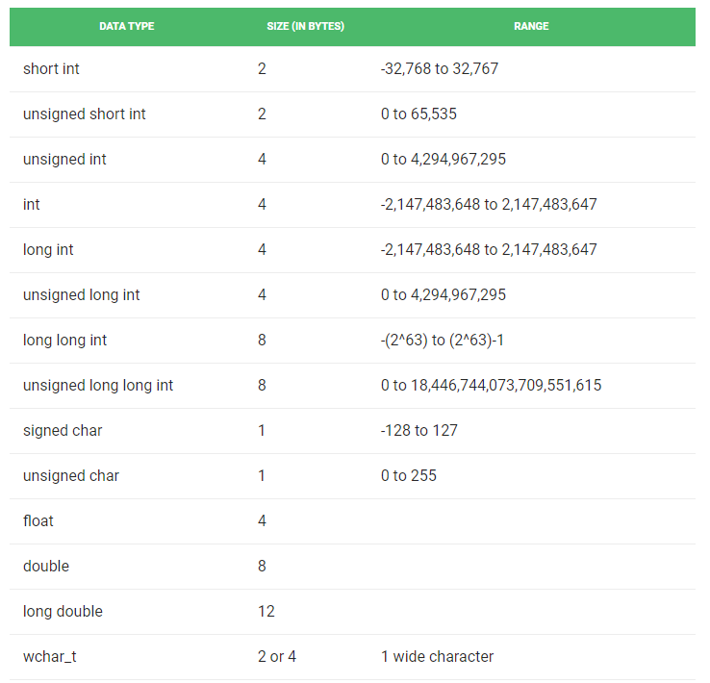

- Q: if a C++ compiler does not support bool type, how could you still use true and false ?
- Declaration of Variables

int a, b, c;
unsigned short NumberOfSons;
signed int MyAccountBalance;

- By default, int is the signed int
- What is ‘unsigned’ ?

- Initialization of Variables
- C-like
type identifier = initial_value ;
int a = 0;

- C++-like
type identifier (initial_value) ;
int a (0);

- Scope of Variables
- What is the scope of a variable ?

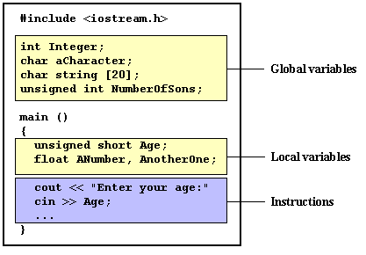
- Can a global variable be seen in another file ?
- Can you declare a variable anywhere in C++ ?

So much for variables

- Character Constant

'z'
'p'
"Hello world"
"How do you do?"
"string expressed in \
two lines"
printf("She said \"time flies like an arrow, but fruit flies like a banana\".");

- Single and double quotes
- A string in two lines
- Escape the quotes with backslashes

- Defined Constants

#define identifier value
#define PI 3.14159265
#define NEWLINE '\n'
#define WIDTH 100

- Declared Constants

const int width = 100;
const char tab = '\t';
const zip = 12440;
- Can you modify the value of a constant ?

Operators
- Definition: mean operations on variables and constants

- Arithmetic operators ( +, -, *, /, % )
- % is called module, which gives the remainder from the division of the left operand by the right operand, eg. left%right → remainder
- what is 5%3 ?

- Compound assignation operators (+=, -=, *=, /=, %=, >>=, <<=, &=, ^=, |=)

value += increase; is equivalent to value = value + increase;
a -= 5; is equivalent to a = a - 5;
a /= b; is equivalent to a = a / b;
- What is the result of price *= units + 1; ?

- Increase and Decrease
- Increase operator (++)
- Decrease operator (--)
- They increase or decrease by 1 the value of a variable.
- Q: What is the difference between A=++B; and A=B++; ?

B=3;
A=++B;
// A is 4, B is 4

B=3;
A=B++;
// A is 3, B is 4

Break

- Relational operators ( ==, !=, >, <, >=, <= )
- Q: What is != ?
- Q: what is the possible output of ( x != y) ?

- Logic operators (!, &&, ||)
- Operate on logic variable (i.e. bool type)
- Q: what is the meaning of these three operators ?

- Conditional operator (?)

condition ? result1 : result2

if condition is true the expression will return result1, if not it will return result2.
7==5 ? 4 : 3

a>b ? a : b What is the output ?

What is a macro ? What is an inline function ?

A macro is a fragment of code which has been given a name. Whenever the name is used, it is replaced by the contents of the macro. (C style)

Inline function is a function that is expanded in line when it is called. When the inline function is called whole code of the inline function gets inserted or substituted at the point of inline function call. (C++ style)

#define getmax(a,b) a>b?a:b

inline int getmax(int a, int b)
{
return (a>b?a:b);
}

- Bitwise operators (&, |, ^, ~, <<, >> )
- Definition: modify the variables by considering the bits that represent the value they store.

OP | asm | Description
& | AND | Logic AND
| | OR | Logic OR
^ | XOR | Logic exclusive OR
~ | NOT | Complement to one
<< | SHL | Shift Left
>> | SHR | Shift Right

Decimal to binary number:
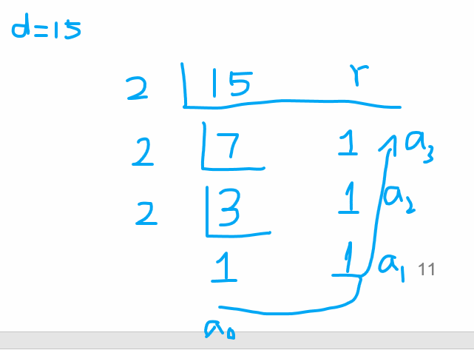

char a=195;
char b=87;
char c;
c=a&b;
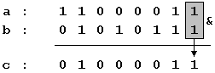
01000011, that is 67.

?

Demo.

int foo (int number, int x)
{
return number << x;
}

int bar (int number, int x)
{
return number >> x;
}

Bitwise shifting left and right:
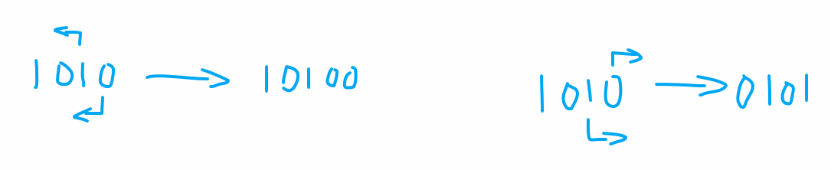

char in_use=0;

int is_in_use (int x)
{
return in_use & 1 << x;
}

XX1XXXXX &
00100000 =
--------
00100000

XX0XXXXX &
00100000 =
--------
00000000

- Explicit type casting operators
- Definition: convert one type of a variable to another type
int i;
float f = 3.14;
i = (int) f;
- Q: what is the result of i ?
- Q: what if there is no type casting ?

- Priority of operators
- Different operators have different priority in a complex math expression
- A complex math expression is evaluated with operators from the greatest priority to lowest priority
- If there are several operators of the same priority level, evaluation may go from left to right or the opposite depending upon the associativity of operators.
Priority | Operator | Description | Associativity
1 | :: | scope | left
2 | ( ) [ ] -> . sizeof |  | left
3 | ++ -- | Increment/decrement | right
3 | ~ | Complement to one | right
3 | ! | Unary NOT | right
3 | & * | Reference and Dereference | right
3 | (type) | Type casting | right
3 | + - | Unary sign | right
4 | * / % | Arithmetical operations | left
5 | + - | Arithmetical operations | left
6 | << >> | Bit shifting | left
7 | < <= > >= | Relational operators | left
8 | == != | Relational operators | left
9 | & ^ | | Bitwise operators | left
10 | && || | Logic operators | left
11 | ? : | conditional | right
12 | = += -= *= /= %=  >>= <<= &= ^= |= | Assignation | right
13 | , | comma | left

a = 5 + 7 % 2
?
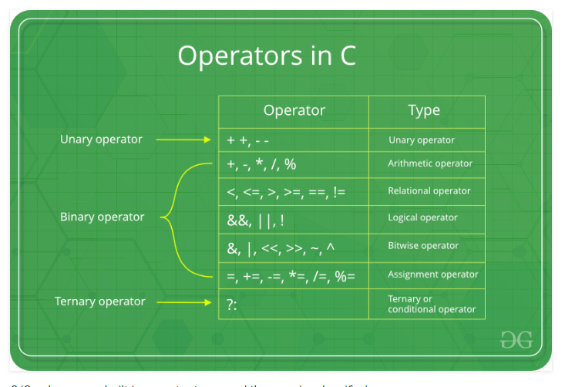
Source: geeksforgeeks

Communication through console
- Console: basic interface of a computer, consists of a keyboard and a screen
- Output to Screen
- cout
- Input from Keyboard
- cin

// i/o example
#include <iostream.h>

int main ()
{
int i;
cout << "Please enter an integer value: ";
cin >> i;
cout << "The value you entered is " << i;
cout << " and its double is " << i*2 << ".\n";
return 0;
}

Please enter an integer value: 702
The value you entered is 702 and its double is 1404.

?
Control Structures
- Rational: A program is not limited to a linear sequence of instructions. It may bifurcate, repeat or take decisions. For that purpose, C++ provides control structures.

- Conditional structures: if and else

if (condition) statement1 else statement2
int x = -2;
if (x > 0)
cout << "x is positive";
else if (x < 0)
cout << "x is negative";
else
cout << "x is 0";

How about “if (x=0)” ?

- Repetitive structures or loops

while (expression) statement
// custom countdown using while
#include <iostream.h>
int main ()
{
int n;
cout << "Enter the starting number > ";
cin >> n;
while (n>0) {
cout << n << ", ";
--n;
n-=1;
}
cout << "FIRE!";
return 0;
}
Enter the starting number > 8

What is the output ?

do statement while (condition);
// number echoer
#include <iostream.h>
int main ()
{
unsigned long n;
do {
cout << "Enter number (0 to end): ";
cin >> n;
cout << "You entered: " << n << "\n";
} while (n != 0);
return 0;
}

What is the output for keyboard input (3, 4, -1, 0 3) ?

for (initialization; condition; increase) statement;
// countdown using a for loop
#include <iostream.h>
int main ()
{
for (int n=10; n>0; n--) {
cout << n << ", ";
}
cout << "FIRE!";
return 0;
}
What is the output ?

?

- Bifurcation of control

// break loop example
#include <iostream.h>
int main ()
{
int n;
for (n=10; n>0; n--) {
if(n==5) continue;
cout << n << ", ";
if (n==3)
{
cout << "countdown aborted!";
break;
}
}
return 0;
}

What is the output ?

- What is functionality of continue and break ?

- Selective structure: switch

switch (expression) {
case constant1:
block of instructions 1
break;
case constant2:
block of instructions 2
break;
.
.
.
default:
default block of instructions
}
switch (x) {
case 1:
case 2:
case 3:
cout << "x is 1, 2 or 3";
break;
default:
cout << "x is not 1, 2 nor 3";
}

- Suited for multiple choices (at least 3)
- What is the functionality of break ?
- What does default mean ?
- What do three cases together mean ?

Quiz:

- Write a complete program that reads in an integer representing a room number, and, using a switch statement, outputs the corresponding room capacity. The room capacity is based on the following data:

ROOM | CAPACITY
426 | 25
327 | 18
420 | 20
317 | 10

For all other room numbers, your program must output the word “Unknown”.

Functions
- Rationale: Using functions we can structure our programs in a more modular way.
- Format

type name (argument1, argument2, ...) statement

- Type - type of data returned by the function
- Name - name of the function
- Arguments – parameters passed in and out of the function
- Statements – the function’s body

// function example
#include <iostream.h>

int addition (int a, int b)
{
int r;
r=a+b;
return (r);
}

int main ()
{
int z;
z = addition (5,3);
cout << "The result is " << z;
return 0;
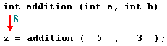
}
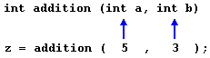
- What is the functionality of return ?
- Scope of variables in a function
- local variables -- within the function

- Functions with no types
- Use of void

// void function example
#include <iostream.h>

void dummyfunction (void)
{
cout << "I'm a function!";
}

int main ()
{
dummyfunction ();
return 0;
}

- Both return type and argument data type
- Do you need return a value for no-type functions?
- Arguments passed by value and by reference *****
- In C++, we have two parameter passing mechanisms: by value and by reference
- By value
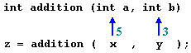
- Definition: the values of real parameters in the calling routine are copied to the formal parameters in the called function

- Q: are the memory locations of x and a same ?
- Q: will the change of a inside the function affect the value of x ?

- By reference
- Definition: the memory addresses of real parameters in the calling routing are assigned to the memory addresses of the formal parameters in the called function
- Implementation
- Adding & to formal parameters, C++ way
// passing parameters by reference
#include <iostream.h>

void duplicate (int& a, int& b, int& c)
{
a*=2;
b*=2;
c*=2;
}

int main ()
{
int x=1, y=3, z=7;
duplicate (x, y, z);
cout << "x=" << x << ", y=" << y << ", z=" << z;
return 0;
}

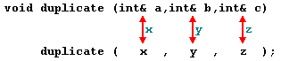

- Using pointers to formal parameters, C way
// passing parameters by reference
#include <iostream.h>

void duplicate (int *a, int *b, int *c)
{
*a *=2;
*b *=2;
*c *=2;
}

int main ()
{
int x=1, y=3, z=7;
duplicate (&x, &y, &z);
cout << "x=" << x << ", y=" << y << ", z=" << z;
return 0;
}

- Will be explained in details later
- Pointer ******

- Default Values in Arguments
- When declaring a function we can specify a default value for each parameter.
// default values in functions
#include <iostream.h>

int divide (int a, int b=2)
{
int r;
r=a/b;
return (r);
}

int main ()
{
cout << divide (12);
cout << endl;
cout << divide (20,4);
return 0;
}
- What is the output of divide (12) ?

- Overloaded functions
- Two different functions can have the same name if the prototypes (?) of their arguments are different

// overloaded function
#include <iostream.h>

int divide (int a, int b)
{
return (a/b);
}

float divide (float a, float b)
{
return (a/b);
}

int main ()
{
int x=5,y=2;
float n=5.0,m=2.0;
cout << divide (x,y);
cout << "\n";
cout << divide (n,m);
return 0;
}

- What is the output ?
- Very useful **

- recursivity
- Definition (?)
- Very important *****
- Example: factorial of a number n

n! = n * (n-1) * (n-2) * (n-3) ... * 1
// factorial calculator
#include <iostream.h>

long factorial (long a)
{
if (a > 1)
return (a * factorial (a-1));
else
return (1);
}

int main ()
{
cout << 3 << "!" << " = " << factorial (3);
return 0;
}

- What is the result ?
- Best way to understand it

- Prototyping functions
- Format

type name ( argument_type1, argument_type2, ...);

// prototyping
#include <iostream.h>

void odd (int a);
void even (int a);

int main ()
{
int i;
do {
cout << "Type a number: (0 to exit)";
cin >> i;
odd (i);
} while (i!=0);
return 0;
}

void odd (int a)
{
if ((a%2)!=0) cout << "Number is odd.\n";
else even (a);
}

void even (int a)
{
if ((a%2)==0) cout << "Number is even.\n";
else odd (a);
}
Arrays
- Definition
- A series of elements (variables) of the same type placed consecutively in memory that can be individually referenced by an index
- Example
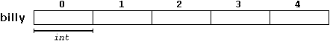

int billy [5];
- Length of array must be a constant
- What is the starting index in Fortran ?

- Initializing arrays

int billy [5] = { 16, 2, 77, 40, 12071 };
int billy [] = { 16, 2, 77, 40, 12071 };

- Access to the values of an Array

name[index]

billy[2] = 75;
a = billy[2];
- Multidimentional Arrays
- Definition: multidimensional arrays can be described as arrays of arrays
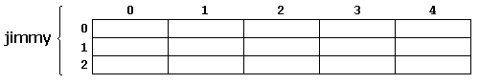
- Example of a 2-d array

int jimmy [3][5];

jimmy[1][3]
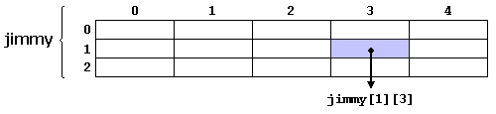
- Example of a 5-d arrays

char century [100][365][24][60][60];

- Q: are the following two arrays equivalent ?

int jimmy [3][5];
int jimmy [15]; (3 * 5 = 15)

- Q: what is the row-major and column-major?

- Multidimensional arrays are nothing else than an abstraction

// multidimensional array
#include <iostream.h>

#define WIDTH 5
#define HEIGHT 3

int jimmy [HEIGHT][WIDTH];
int n,m;

int main ()
{
for (n=0;n<HEIGHT;n++)
for (m=0;m<WIDTH;m++)
{
jimmy[n][m]=(n+1)*(m+1);
}
return 0;
}

// pseudo-multidimensional array
#include <iostream.h>

#define WIDTH 5
#define HEIGHT 3

int jimmy [HEIGHT * WIDTH];
int n,m;

int main ()
{
for (n=0;n<HEIGHT;n++)
for (m=0;m<WIDTH;m++)
{ jimmy[n*WIDTH+m]=(n+1)*(m+1);
}
return 0;
}

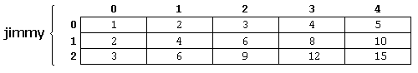

- Arrays as parameters
- Sometime we need to pass an array to a function
- Q: can we pass an array by value ?
- Q: why is the passing by reference efficient ?

// arrays as parameters
#include <iostream.h>

void printarray (int arg[], int length) {
for (int n=0; n<length; n++)
cout << arg[n] << " ";
cout << "\n";
}

int main ()
{
int firstarray[] = {5, 10, 15};
int secondarray[] = {2, 4, 6, 8, 10};
printarray (firstarray,3);
printarray (secondarray,5);
return 0;
}

- Q: what does the array name mean ?
- Q: what about passing a 2-d array ?

Debugging
- An important practical skill you should have in your future software development
- Types
- Cout
- Comment out
- Break points (regular and conditional) through Visual Studio
- Assert( )

This Week’s Lecture

- C-portions of C++ Languages
- Basics of C++
- Control Structures and Functions
- Advanced Data

Next Lecture

- Software Design Process

